Projectile Motion Weekly Problem 2

2) When air resistance is added, the ball's velocity in both the x and y directions should decrease over time and the ball will not go as far.

3) For a drag coefficient of just .002, the ball’s trajectory is not greatly affected. For a greater drag coefficient, we start to see a much greater impact on the trajectory of the ball

Trajectories for when drag=.002 and velocity=10

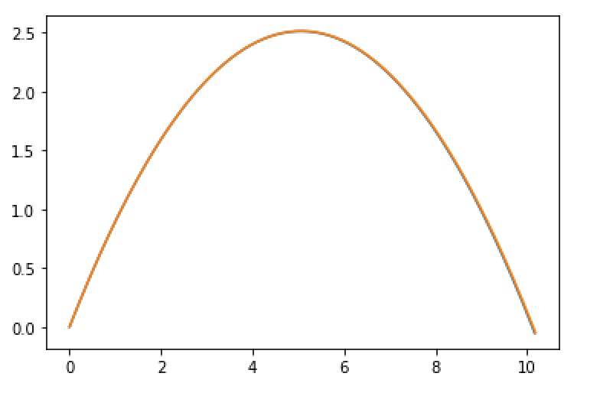

Trajectories for when drag=.5 and velocity=10

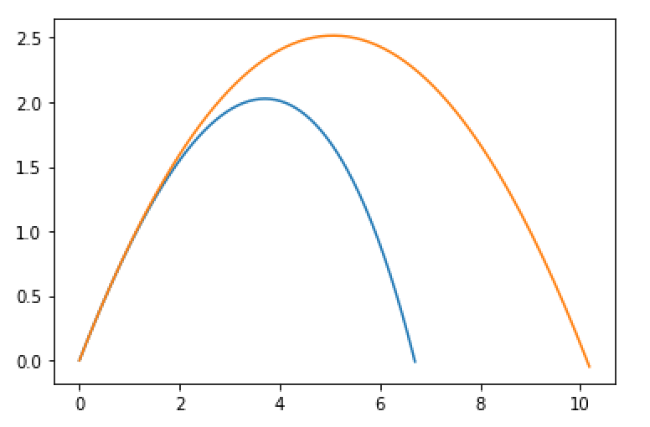

Trajectories for when drag=.002 and velocity=1000

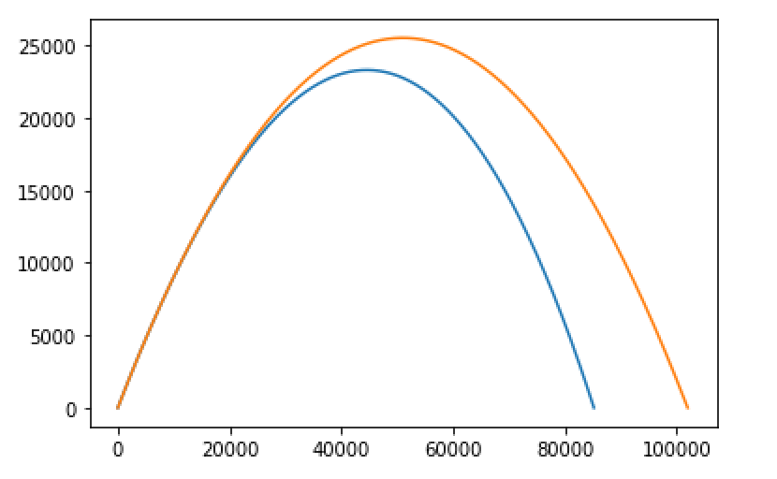

4) From these plots a couple of things can be determined. We can model the trajectory of a ball in air with a low velocity pretty accurately by solving for the trajectory without taking drag into account. Air resistance is small enough that it will not throw the results off. When the drag coefficient is high or the velocity is high there is enough drag to create enough of a difference that air resistance must be taken into account.

Trajectory for when drag=.002 and velocity=10 and g=.01

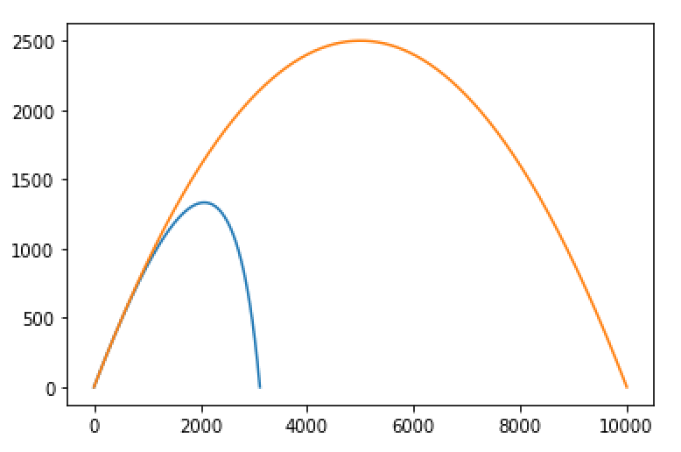

6) When gravity is very small, the difference between the trajectory without air resistance and the trajectory with air resistance is large.

7) If the ball has a negative mass the code still runs but the plot is incorrect because it isn’t possible for the ball to have a negative mass. The code can be broken by setting everything to zero and trying to run the code. It ends up infinitely looping.